**Computer Programming**

Lab File submitted

in partial fulfilment of the

requirements for the degree of

**BACHELORS OF TECHNOLOGY**

**In**

**Electrical Engineering**

By

**Riddhi Dhawan**

(2023UEE4611)



To The

Department of Information Technology

**NETAJI SUBHASH UNIVERSITY OF TECHNOLOGY**

Azad Hind Fauj Marg,Sector-3,Dwarka,New Delhi-110078

# INDEX

|  |  |  |
| --- | --- | --- |
| **S.NO.** | **TOPICS** | **DATE** |
| 1. | WRITE A PROGRAM TO CHECKWHETHER A STRING IS A PALINDROMEOR NOT | 19/01/24 |
| 2. | WRITE A PROGRAM FOR MAKING AN EMPTY LIST AND APPENDING VALUES | 19/01/24 |
| 3. | WRITE A PROGRAM FOR PRINTING FIBONACCI SEQUENCE | 2/02/24 |
| 4. | WRITE A PROGRAM FOR PRINTING FACTORIAL OF A NUMBER | 2/02/24 |
| 5. | WRITE A PROGRAM FOR TAKING INPUT AND PRINTING ONLY EVEN  VALUES IN A LIST | 9/02/24 |
| 6. | WRITE A PROGRAM FOR WRITING A CLASS FOR FIBONACCI SEQUENCE | 6/03/24 |
| 7. | WRITE A PROGRAM USING MAP , FILTER , LAMBDA AND ZIP FUNCTIONS | 6/03/24 |

# MORE ABOUT PYTHON

Python is a high-level, interpreted programming language known for its simplicity and readability. Python's design philosophy emphasizes code readability with its use of significant indentation, making it easier to understand and write clean code.

Here are some key features and aspects of Python:

1. General-Purpose: Python is a versatile language used for a wide range of applications such as web development, data analysis, artificial intelligence, scientific computing, automation, and more.

2. Interpreted: Python code is executed line by line by the Python interpreter, rather than compiled into machine code. This allows for rapid development and testing.

3. Easy to Learn and Read: Python's syntax is designed to be simple and readable, making it accessible for beginners and enjoyable for experienced programmers.

4. Dynamic Typing: Python uses dynamic typing, meaning you don't need to declare variable types explicitly. Variable types are inferred at runtime.

5. Strong Typing: Despite dynamic typing, Python is strongly typed, meaning it won't allow operations between incompatible types.

6. Object-Oriented: Python supports object-oriented programming (OOP) principles, including classes, objects, inheritance, and encapsulation.

7. High-level Data Structures: Python provides built-in high-level data structures such as lists, dictionaries, sets, and tuples, making it efficient for data manipulation and processing.

QUES 1

WRITE A PROGRAM TO CHECKWHETHER A STRING IS A PALINDROMEOR NOT

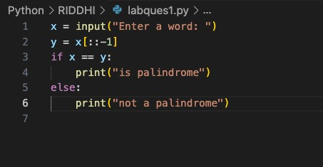

QUES 2

WRITE A PROGRAM FOR MAKING AN EMPTY LIST AND APPENDING VALUES

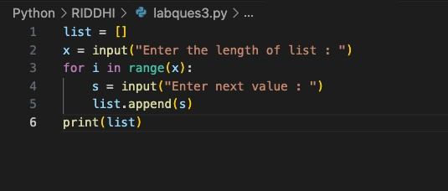

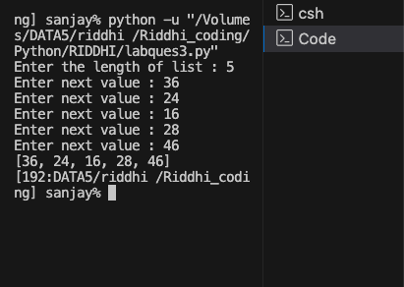

QUES 3

WRITE A PROGRAM FOR PRINTING FIBONACCI SEQUENCE

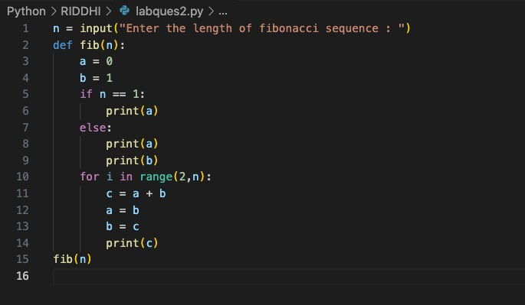

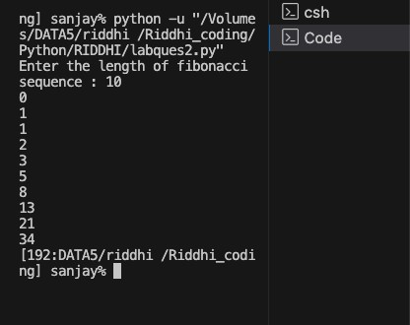

QUES 4

WRITE A PROGRAM FOR PRINTING FACTORIAL OF A NUMBER

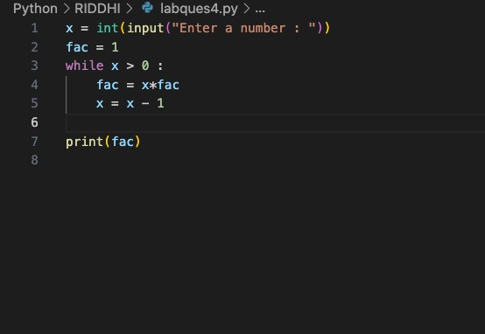

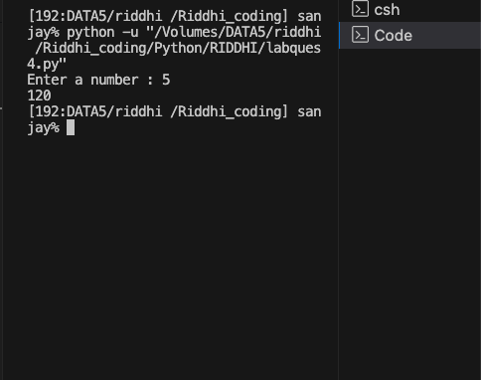

QUES 5

WRITE A PROGRAM FOR TAKING INPUT AND PRINTING ONLY EVEN VALUES IN A LIST

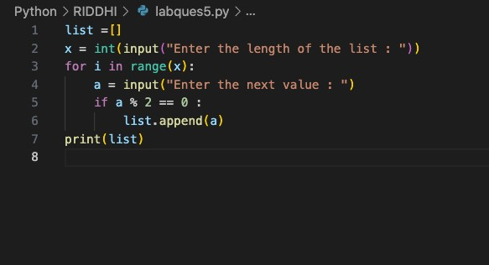

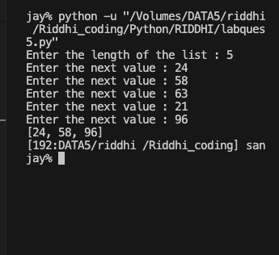

QUES 6

WRITE A PROGRAM FOR WRITING A CLASS FOR FIBONACCI SEQUENCE

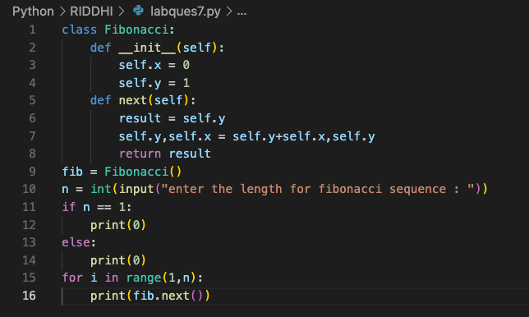

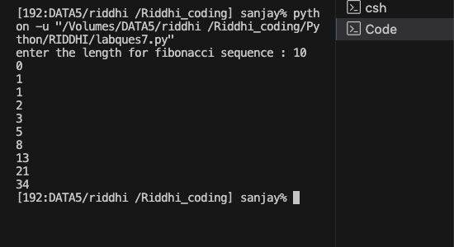

QUES 7

WRITE A PROGRAM USING MAP , FILTER , LAMBDA AND ZIP FUNCTIONS

